SHEQ Safety Performance Report
Safety Energy, event risk, and leadership focus areas

Report Scope
Events window: 08 Jul 2023 – 31 Dec 2025. Leading activity window: 01 Jan 2024 – 31 Dec 2025. Built for senior leaders as a concise decision-support pack rather than a compliance summary.

Generated  09 Apr 2026 | Events Coverage  08 Jul 2023 to 31 Dec 2025
Safety Energy Coverage  01 Jan 2024 to 31 Dec 2025 | Audience  Executive / Board

1. Executive Summary
Leadership Readout
This summary highlights where event risk is concentrated, where leading activities appear strongest or weakest, and what senior leaders should prioritise next.

Total Events  2621 | Moderate+ Events  88 | Events / Month  109.2 | Motor Vehicle Events  279
LLCs  5954 | CCCs  7730 | OCCs  5789 | CCC Avg Quality  28.2

1.1 What Leaders Should Know
- CCCs averaged a quality score of 28.2/100 over the last 24 months, with 68.3% assessed as shallow and 1.4% assessed as high value.
- Resources shows a high-volume / low-value pattern in CCC activity: 2869 records with average quality 28.7 and 67.7% shallow entries.
- Emerging Safety Energy themes in the recent six months include Grinder, Quality Inspection Checklist, Thermal Stress.
- LLC records currently show the strongest overall documentation quality among the three leading activity types.

1.2 Board Visual Snapshot
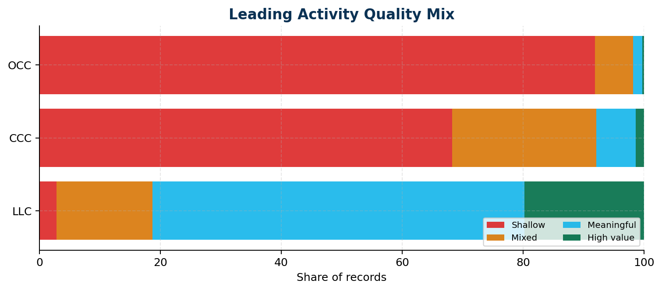

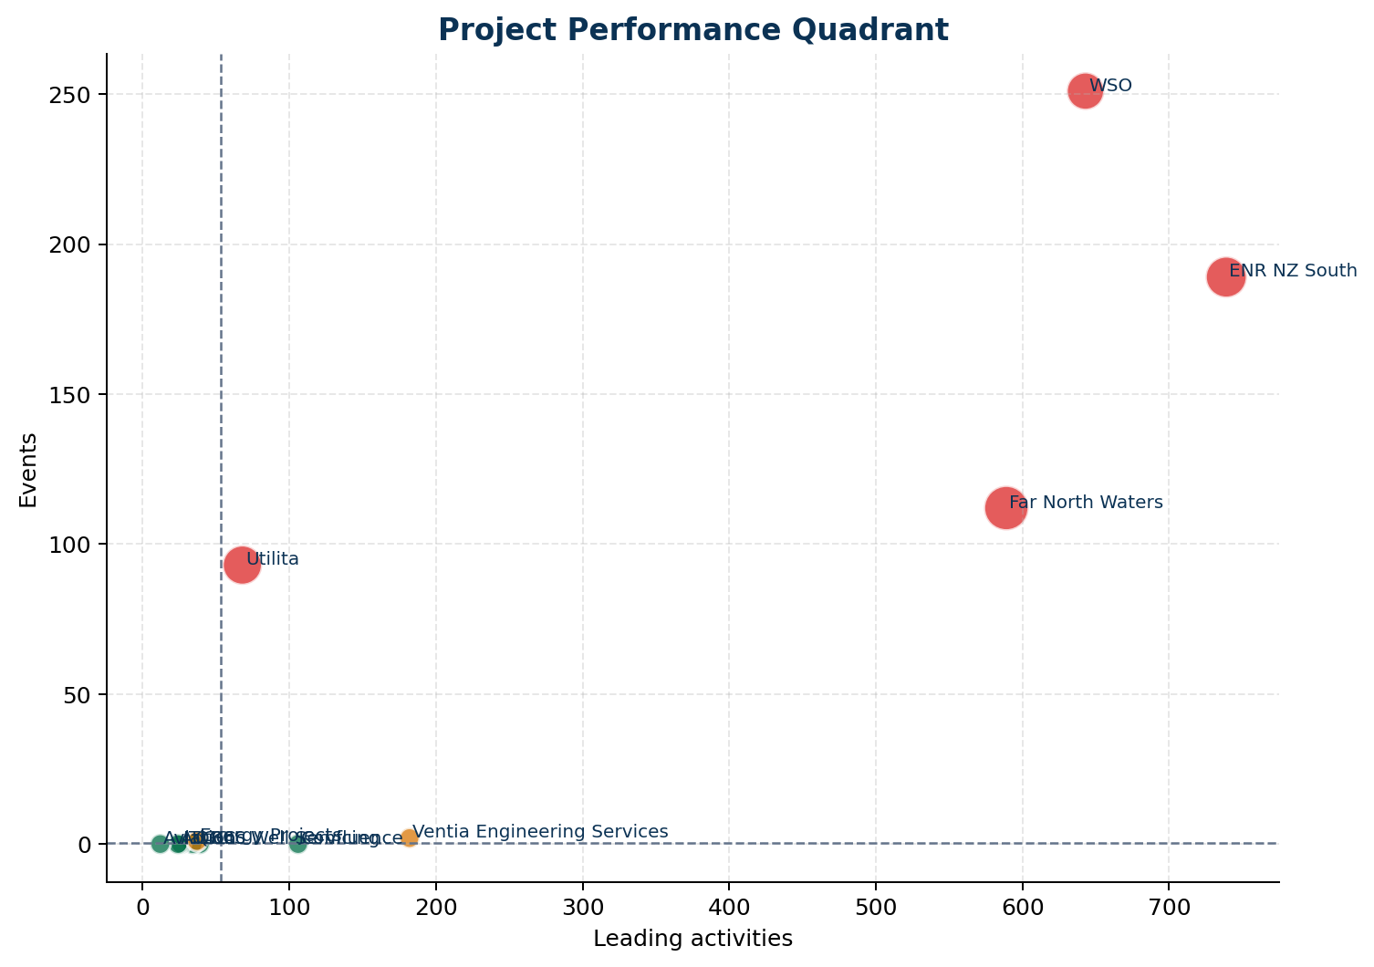

1.3 Priority Actions
Recommended Action
Moderate-or-above consequence events make up 3.4% of recorded events. Review whether controls around the highest-consequence scenarios are being verified often enough in field activity.

Recommended Action
31 Lost Time Injuries were recorded in the analysis window. Review the underlying work types, contributing factors, and recovery actions for common patterns.

Recommended Action
Serious events are most frequently recorded in Afternoon (12:00-17:59). Use this to target pre-start, supervision, and fatigue controls at the riskiest parts of the day.

Recommended Action
Motor vehicle events account for 10.6% of all events. Review journey management, road conditions, and vehicle type patterns in the MVE section.

Recommended Action
Prioritise a motor vehicle risk review for Yarra Valley Water O&M where MV exposure is most visible, with particular attention to Main Road driving conditions.

2. Data Quality and Coverage
This section summarises the completeness and date coverage of each data source. Any gaps identified here may affect the reliability of subsequent analysis sections.

Events
Field | Value
Rows | 2637
Date From | 08 Jul 2023
Date To | 31 Dec 2025
Null — Event Type | 0.0%
Null — Consequence | 0.0%
Null — Business Unit | 0.0%
Null — Root Cause | 0.6%

Safety Energy
Field | Value
Rows | 19473
Date From | 01 Jan 2024
Date To | 31 Dec 2025
Null — Leader | 0.0%
Null — Business Unit | 0.0%

Activity Type | Count
CCC | 7730
LLC | 5954
OCC | 5789

LLC Data
Field | Value
Rows | 5951
Date From | 01 Jan 2024
Date To | 31 Dec 2025
Null — Topic | 0.1%
Null — Leader | 0.0%

3. Events Analysis
Event Story
This section focuses on where event burden is building, where serious outcomes are concentrated, and what special risk signals are visible in timing and motor vehicle data.

3.1 Monthly Trend
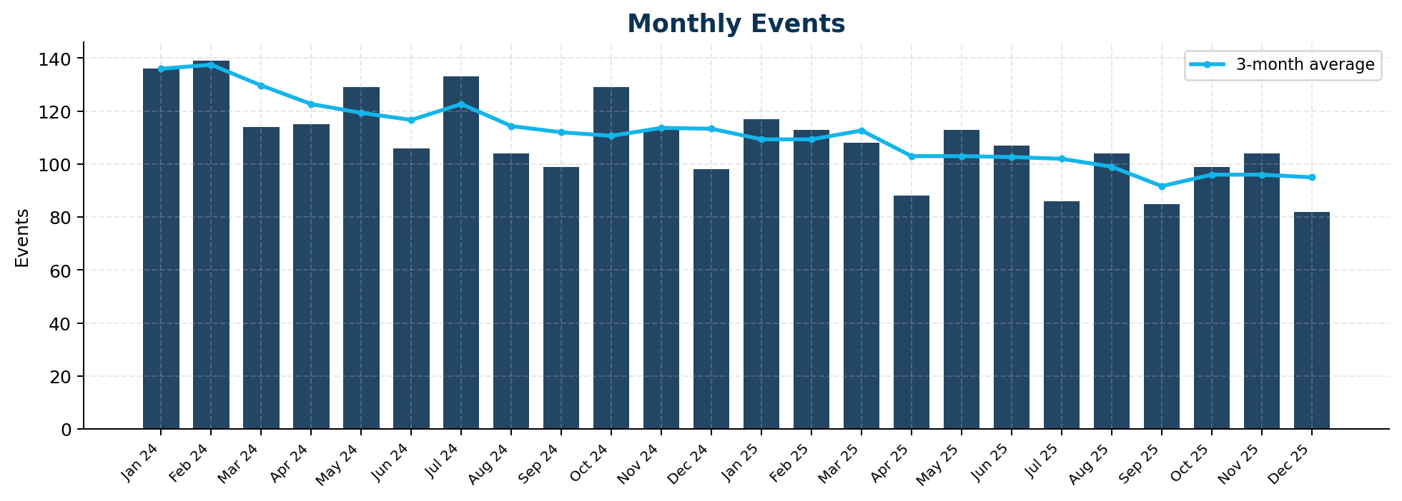

3.2 Consequence Severity
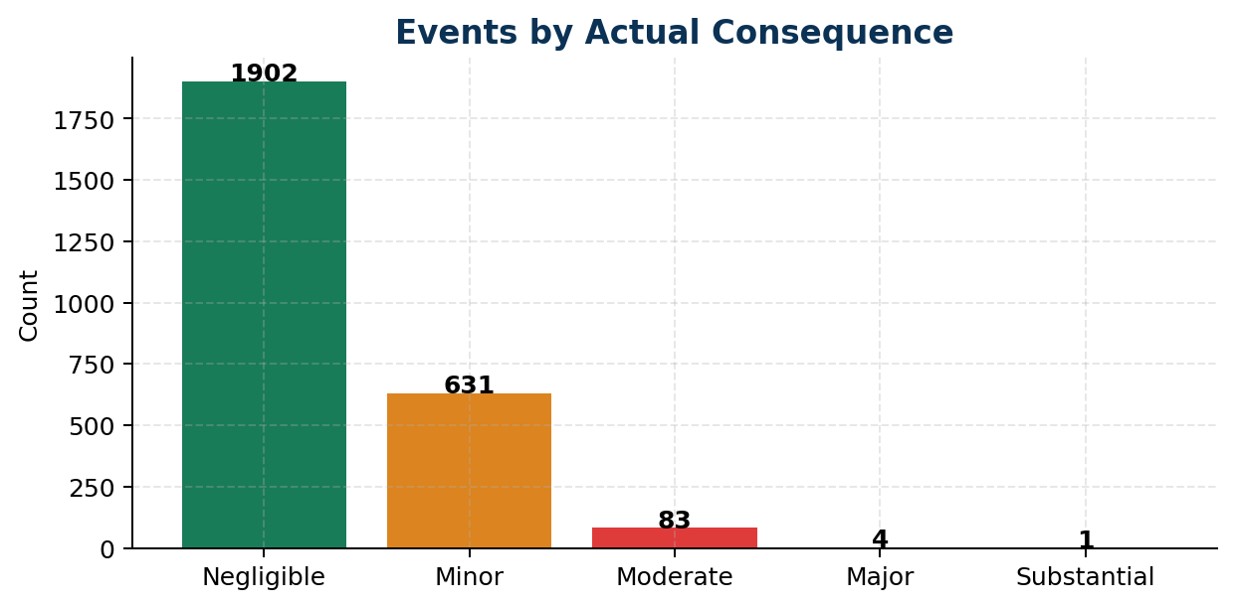

3.3 Event Type Breakdown
Event Type | Count | %
Injury/Illness Sustained | 1084 | 41.4%
Equipment/Property Damage | 430 | 16.4%
Motor Vehicle | 279 | 10.6%
Close Call | 256 | 9.8%
Nonconformance | 181 | 6.9%
Environment | 110 | 4.2%
Utility Strike | 98 | 3.7%
Third Party/Public Liability | 77 | 2.9%
Security | 75 | 2.9%
Compliance breach/notice | 21 | 0.8%
Assault | 10 | 0.4%

3.4 Critical Risk Protocols Involved
CRP | Count
CRP-Mobile Plant | 141
CRP-Driving & Remote Travel | 137
CRP-Driving and Remote Travel | 119
CRP-Hazardous Energy | 54
CRP-Lifting Operations | 49
CRP-Live Services | 39
CRP-Excavations | 38
CRP-Hazardous Substances | 37
CRP-Hazardous Energies | 35
CRP-Working Near Live Services | 25

3.5 Root Cause Categories
Root Cause | Count
External Factors | 986
People | 965
Production / Delivery | 324
Process | 226
Planning | 86
Providers | 20

3.6 Serious Event Hotspots
These are the projects and locations with the highest counts of moderate, major, or substantial events in the analysis window.
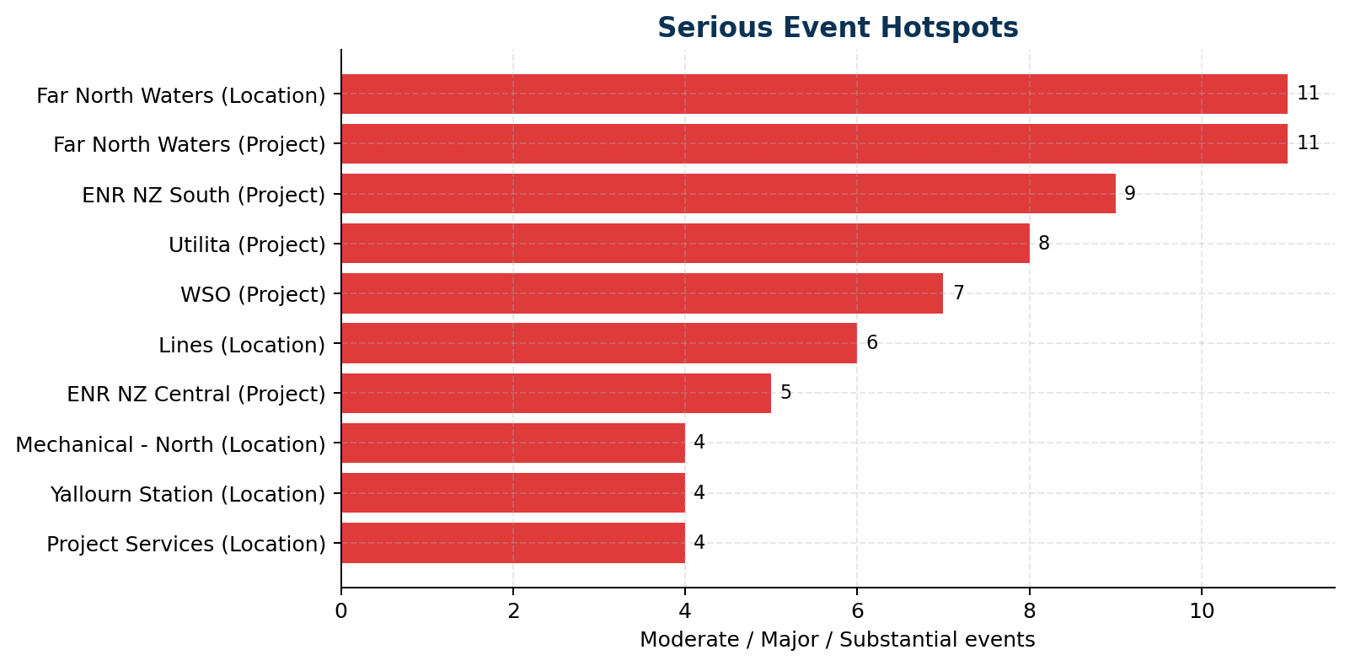

Project | Serious Events
Far North Waters | 11
ENR NZ South | 9
Utilita | 8
WSO | 7
ENR NZ Central | 5
Project Services | 5
Yarra Valley Water O&M | 4
ENR Aust - QLD | 4

Location | Serious Events
Far North Waters | 11
Lines | 6
Project Services | 4
Yallourn Station | 4
Mechanical - North | 4
Stations | 3
Generation | 3
Industrial and Distribution | 2

3.7 Serious Event Timing
Time-of-day information was available for 100.0% of serious events.
Time of Day | Serious Events
Afternoon (12:00-17:59) | 40
Morning (06:00-11:59) | 30
Evening (18:00-23:59) | 14
Night (00:00-05:59) | 4

3.8 Motor Vehicle Events
Metric | Value
Total Motor Vehicle Events | 279
Share of All Events | 10.6%
Moderate+ MV Events | 7
Serious Rate Within MV Events | 2.5%

Project | MV Events
Yarra Valley Water O&M | 37
ENR Aust - QLD | 30
ENR NZ South | 30
Utilita | 22
ENR NZ North | 22
Water Environmental Monitoring | 13
Far North Waters | 12
SEQWater Collaborative Asset Services | 12

Category | Pattern | Count
Road Type | Main Road | 82
Road Type | Drive/Carpark | 76
Road Type | Off Road | 53
Road Type | Quiet Street | 45
Road Condition | Sealed | 208
Road Condition | Unsealed | 70
Vehicle Type | Light Vehicle | 203
Vehicle Type | Heavy Vehicle | 75

4. Safety Energy — Leading Activity Overview
Leading Activity Readout
Safety Energy combines LLC, CCC, and OCC activity. The deeper two-year review is designed to show not just volume, but whether the records look rich, preventive, and useful for leadership learning.

4.1 Activity Type Mix
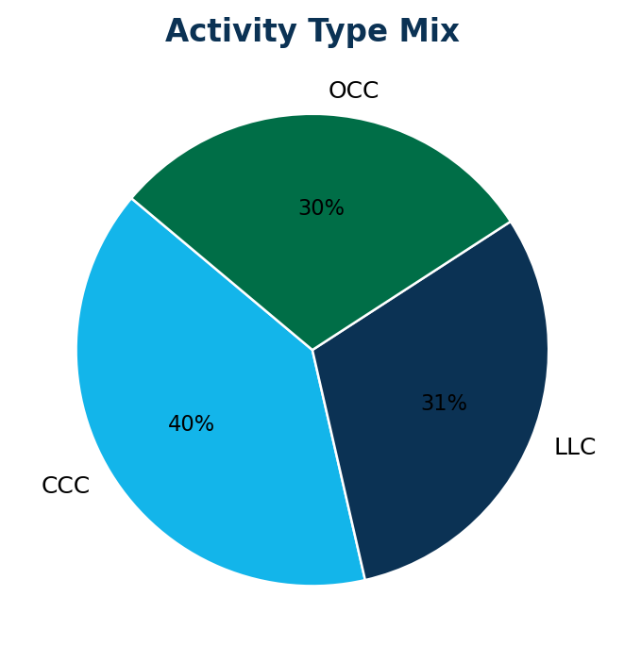

Activity Type | Total Count | Avg At-Risk Aspects per Activity
LLC | 5954 | 0.41
CCC | 7730 | 0.16
OCC | 5789 | 0.24

4.2 Monthly Activity Trend
Overall trend: stable (+8%)
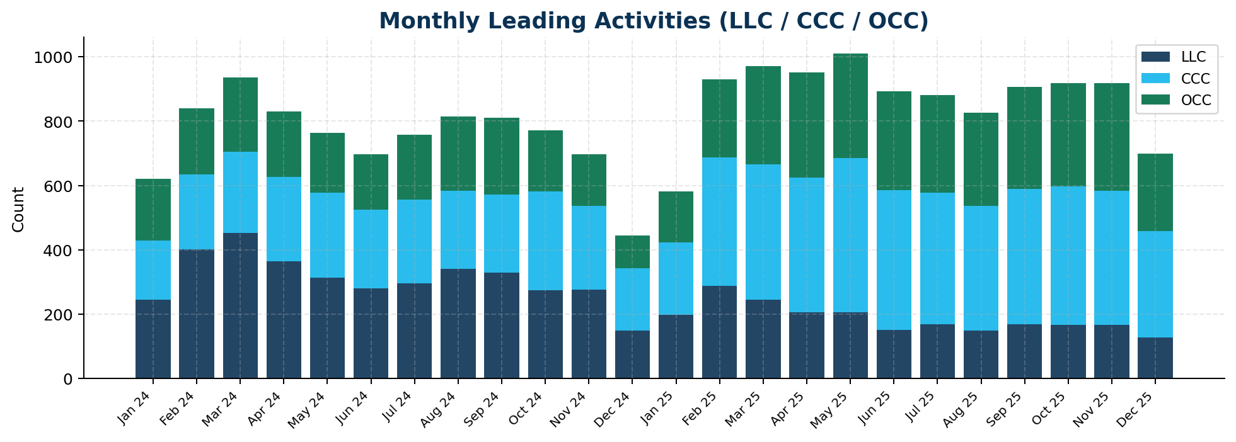

4.3 Activity by Business Unit
Business Unit | LLC | CCC | OCC
Energy & Renewables | 1055 | 2288 | 1872
Professional Services | 158 | 4 | 24
Resources | 3627 | 2869 | 2375
Sector Overhead | 36 | 2 | 4
Water & Environmental Services | 1078 | 2567 | 1514

4.4 LLC Conversation Topics
The following topics were most frequently recorded in Leader Learning Conversations. Topic coverage indicates where leaders are directing their field conversations.
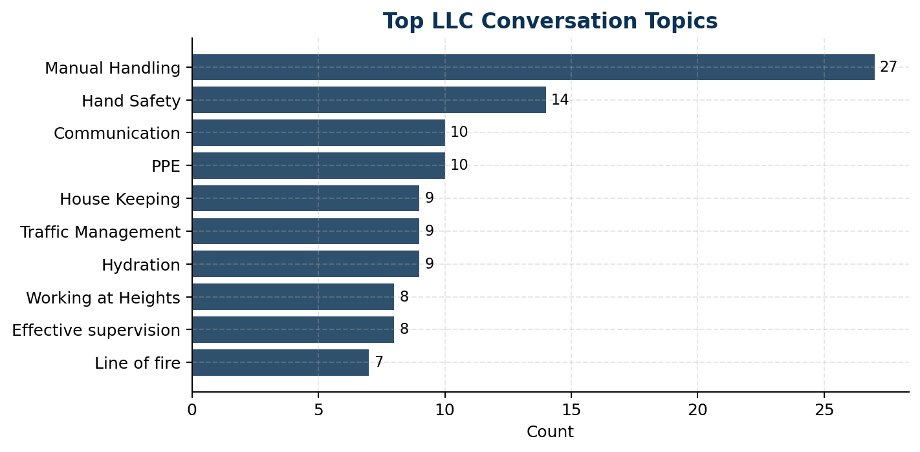

Topic | Count
Manual Handling | 27
Hand Safety | 14
PPE | 10
Communication | 10
Hydration | 9
Traffic Management | 9
House Keeping | 9
Effective supervision | 8
Working at Heights | 8
Line of fire | 7
Lifting Operations | 6
see attached | 6

4.5 CRP Focus Areas in LLCs
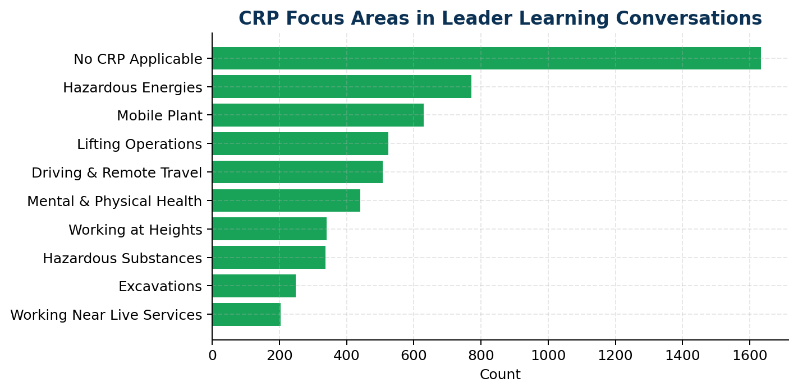

4.6 Most Active Leaders (LLC)
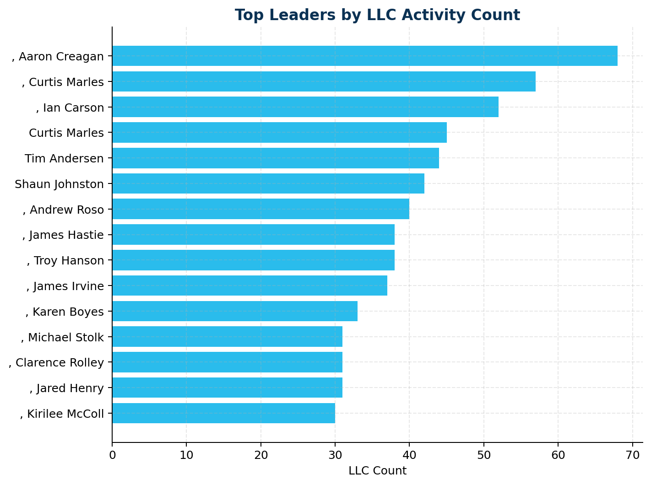

Leader | LLC Count
, Aaron Creagan | 68
, Curtis Marles | 57
, Ian Carson | 52
Curtis Marles | 45
Tim Andersen | 44
Shaun Johnston | 42
, Andrew Roso | 40
, Troy Hanson | 38
, James Hastie | 38
, James Irvine | 37
, Karen Boyes | 33
, Jared Henry | 31

4.7 Rolling Two-Year Trend and Quality View
This view uses a rolling two-year Safety Energy window from 2024-01-01 to 2025-12-31. It is designed to answer not just whether activities were completed, but whether the records suggest meaningful learning, risk recognition, and follow-up quality.
Quality is inferred using practical proxies: richness and specificity of text, risk recognition, action/follow-up language, evidence of learning, input depth across useful fields, and penalties for generic or repeated wording. These scores indicate likely value, not definitive assurance.
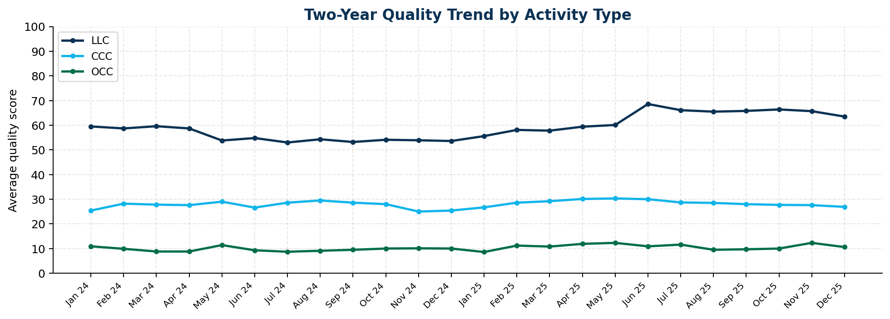

Type | Count | Avg Quality | Avg Input Depth | Meaningful | High Value | Shallow | Follow-up
LLC | 5954 | 58.2 | 55.9 | 61.5% | 19.8% | 2.8% | 42.2%
CCC | 7730 | 28.2 | 40.2 | 6.5% | 1.4% | 68.3% | 16.4%
OCC | 5789 | 10.4 | 34.3 | 1.5% | 0.3% | 91.9% | 10.0%

4.8 Input Depth as a Supporting Quality Metric
Across the two-year Safety Energy window, input depth and quality score are correlated at r = 0.82. Input depth appears usable as a supporting quality metric.
Band | Count | Avg Input Depth | Avg Quality | Meaningful | High Value | Shallow
Light | 7266 | 33.3 | 10.6 | 0.8% | 0.1% | 92.9%
Balanced | 9867 | 45.6 | 41.2 | 26.6% | 7.3% | 40.4%
Rich | 2340 | 64.0 | 60.3 | 66.9% | 24.9% | 1.2%

Most common recurring themes in Safety Energy narratives:
- Traffic/MVA: 3219 mentions
- Manual Handling: 2621 mentions
- PPE: 2202 mentions
- Working at Height: 2063 mentions
- CRP Compliance: 1997 mentions

4.9 CCC / OCCC / LLC Value Signals
CCC: average quality 28.2/100, average input depth 40.2/100, 28.3% preventive signal, 8.8% reactive signal, 19.1% repetitive signal, 68.3% shallow.
For CCC, input depth vs quality correlation is r = 0.75.
Top CCC focus areas:
- Working Around and Operating Mobile Plant: 1034
- Lifting Operations: 906
- Driving and Remote Travel: 905
- Hazardous Energies: 891
OCC: average quality 10.4/100, average input depth 34.3/100, 7.3% preventive signal, 4.9% reactive signal, 23.4% repetitive signal, 91.9% shallow.
For OCC, input depth vs quality correlation is r = 0.66.
Top OCC focus areas:
- Manual Handling: 756
- Bunting and Barricades: 535
- HSE Inspections: 512
- Hand and Portable Power Tool: 454
LLC: average quality 58.2/100, average input depth 55.9/100, 75.7% preventive signal, 12.3% reactive signal, 0.5% repetitive signal, 2.8% shallow.
For LLC, input depth vs quality correlation is r = 0.30.
Top LLC focus areas:
- Leader Learning Conversation: 5954

5. Effectiveness of Leading Activities
This section examines whether leading activity patterns appear associated with event outcomes at a business unit and portfolio level. All findings are associative only — correlation does not imply causation.

5.1 Monthly Activities vs Events Overlay
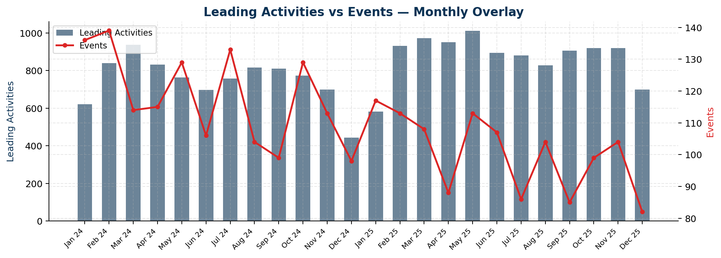

5.2 Statistical Association
A weak negative association (r = -0.18) was observed between monthly leading-activity counts and monthly event counts across 24 overlapping months. No strong directional association was identified.

5.3 Activities vs Events by Business Unit
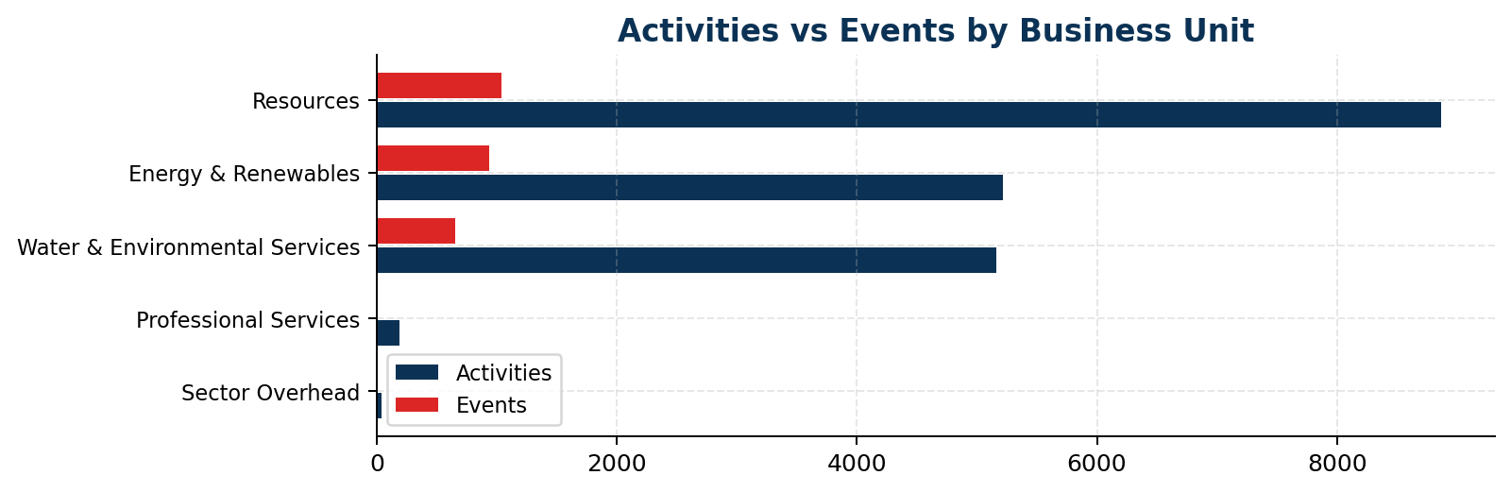

Business Unit | Leading Activities | Events
Resources | 8871 | 1036
Energy & Renewables | 5215 | 932
Water & Environmental Services | 5159 | 650
Professional Services | 186 | 2
Sector Overhead | 42 | 1

5.4 High Activity / High Events — Pattern of Interest
The following Business Units recorded both above-median leading-activity volumes and above-median event counts. This may indicate reactive activity patterns where engagement is increasing in response to events rather than preventing them. Further investigation is recommended.
- Resources
- Energy & Renewables
- Water & Environmental Services

Effectiveness analysis uses business unit-level and monthly aggregates. All associations are indicative only — correlation does not imply causation.

6. At-Risk Behaviours
At-risk behaviour themes are identified by analysing free-text fields across all three data sources (Events descriptions, LLC conversation notes, and Safety Energy observations) using keyword matching against known risk categories.

6.1 Combined Theme Frequency
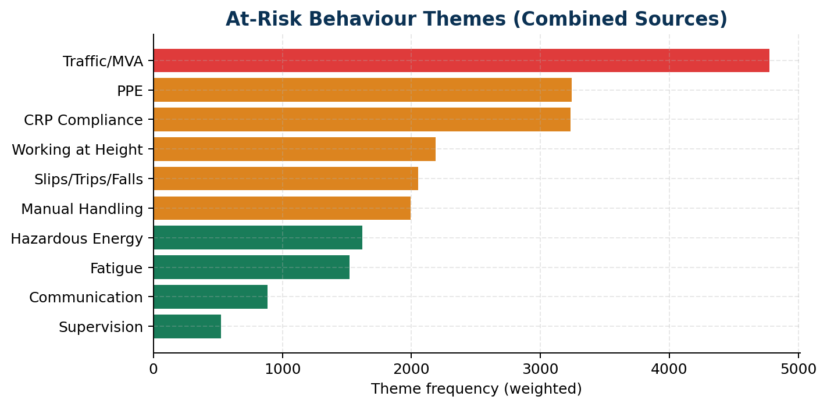

Risk Theme | Weighted Frequency
Traffic/MVA | 4776
PPE | 3244
CRP Compliance | 3233
Working at Height | 2190
Slips/Trips/Falls | 2054
Manual Handling | 1994
Hazardous Energy | 1620
Fatigue | 1520
Communication | 884
Supervision | 522

6.2 LLC Conversation Topics vs Event Themes
Risk Theme | LLC Mentions | Event Mentions
CRP Compliance | 2389 | 112
Communication | 340 | 102
Fatigue | 469 | 291
Hazardous Energy | 606 | 204
Manual Handling | 1095 | 164
PPE | 784 | 838
Slips/Trips/Falls | 532 | 495
Supervision | 216 | 45
Traffic/MVA | 1807 | 925
Working at Height | 944 | 321

6.3 Topic Alignment Gaps
The following risk themes appear among the top event themes but are under-represented in LLC conversation topics. This may indicate a gap between where safety conversations are focused and where actual events are occurring.
- Slips/Trips/Falls
- Fatigue

Theme extraction uses keyword matching against free-text fields. Results are indicative; manual review of underlying records is recommended before drawing firm conclusions.

7. Relationship Between Safety Energy and Events
Coverage vs Outcome
This section links leading activity coverage to event burden so leaders can see which business units, projects, and locations appear strongest, and which need direct intervention.

7.1 Business Unit Comparison
Business Unit | Activities | Events | Activity:Event Ratio
Energy & Renewables | 5215 | 932 | 5.6
Professional Services | 186 | 2 | 93.0
Resources | 8871 | 1036 | 8.6
Sector Overhead | 42 | 1 | 42.0
Water & Environmental Services | 5159 | 650 | 7.9

7.2 Project Performance Signals
These project comparisons use recorded Safety Energy activity against recorded events. They are intended as directional signals only, not league tables.

Project | Activities | Events | Serious | Activity:Event
Confluence | 106 | 0 | 0 | —
GCIS | 39 | 0 | 0 | —
QGC | 34 | 0 | 0 | —
IT | 26 | 0 | 0 | —
Ad Hoc Well Servicing | 24 | 0 | 0 | —
Aviation | 12 | 0 | 0 | —
Energy Projects | 37 | 1 | 0 | 37.0
Ventia Engineering Services | 182 | 2 | 0 | 91.0

Projects needing leadership attention:
Project | Activities | Events | Serious | Activity:Event
Far North Waters | 589 | 112 | 11 | 5.3
ENR NZ South | 739 | 189 | 9 | 3.9
Utilita | 68 | 93 | 8 | 0.7
WSO | 643 | 251 | 7 | 2.6
ENR NZ Central | 827 | 156 | 5 | 5.3
Project Services | 656 | 73 | 5 | 9.0

7.3 Location Performance Signals
Location | Activities | Events | Serious | Activity:Event
Integrated Teams | 144 | 0 | 0 | —
Zinfra | 78 | 0 | 0 | —
Port of Brisbane | 62 | 0 | 0 | —
Labour Services | 67 | 1 | 0 | 67.0
Lavarack Barracks | 65 | 1 | 0 | 65.0
Powerlink BCWF Connection | 34 | 1 | 0 | 34.0
Project Stations | 31 | 1 | 0 | 31.0
ROMA01 Typhoon | 11 | 1 | 0 | 11.0

Locations needing leadership attention:
Location | Activities | Events | Serious | Activity:Event
Far North Waters | 0 | 112 | 11 | 0.0
Lines | 486 | 130 | 6 | 3.7
Project Services | 570 | 68 | 4 | 8.4
Mechanical - North | 16 | 26 | 4 | 0.6
Yallourn Station | 0 | 18 | 4 | 0.0
Stations | 888 | 135 | 3 | 6.6

7.4 Event Spike Periods
The following periods recorded above-average event counts coinciding with below-average leading-activity volumes. These periods may warrant retrospective review.
- 2024-01
- 2024-05
- 2024-07
- 2024-10

7.5 Topic Alignment Observation
LLC topic focus and event root causes are compared to identify alignment gaps. Where event root causes diverge from LLC discussion topics, this may indicate that leading activity conversations are not yet targeting the highest-risk themes.
Top event root causes:
- External Factors
- People
- Production / Delivery
- Process
- Planning

Monthly comparison covers periods where both datasets have data. Short overlapping periods reduce the reliability of any trend observations. This analysis is associative only.

8. Leader Focus Areas
This section identifies Business Units and leaders that warrant specific leadership attention based on activity volumes, event rates, and observed trends.

8.1 Business Unit Activity and Event Summary
Business Unit | Leading Activities | Events
Energy & Renewables | 5215 | 932
Professional Services | 186 | 2
Resources | 8871 | 1036
Sector Overhead | 42 | 1
Water & Environmental Services | 5159 | 650

8.2 Declining Activity Units
The following Business Units recorded significantly lower leading-activity volumes in the second half of the analysis period compared to the first half. Leaders in these units should be engaged to understand and address the decline.
- Sector Overhead

8.3 Leadership Watchouts from Two-Year Safety Energy Trends
- CCC focus on CRP Compliance, Working at Height, Hazardous Energy has reduced in the recent six months; confirm this is intentional rather than a blind spot.
- Previously visible themes such as CRP Compliance, Working at Height, Fatigue are appearing less often in recorded activity narratives.
- A relatively low share of CCCs contain clear follow-up or close-out signals, which weakens the evidence that issues identified in checks are being converted into learning and action.
- Rows with richer input depth are materially more likely to read as meaningful records, so populated-field depth can be used as a practical early warning metric for declining quality.

8.4 High-Volume / Low-Value Hotspots
These areas are recording substantial activity volume, but the record quality signals suggest the activity may be drifting toward compliance-only completion rather than strong learning.
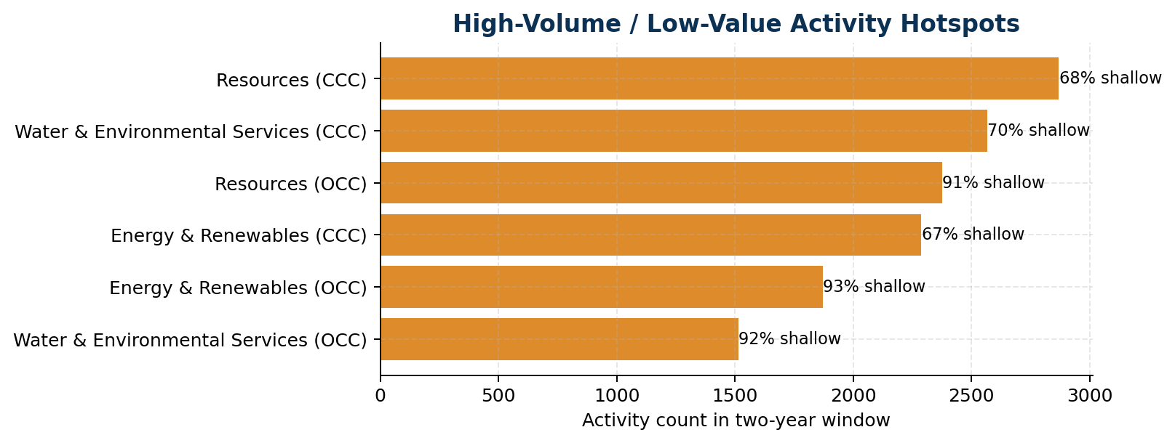

Type | Business Unit | Count | Avg Quality | Shallow
CCC | Resources | 2869 | 28.7 | 67.7%
CCC | Water & Environmental Services | 2567 | 27.4 | 70.5%
OCC | Resources | 2375 | 11.4 | 91.2%
CCC | Energy & Renewables | 2288 | 28.6 | 66.7%
OCC | Energy & Renewables | 1872 | 8.8 | 93.1%
OCC | Water & Environmental Services | 1514 | 10.7 | 91.8%

9. Recommended Actions
Action Agenda
These actions are generated directly from the event hotspots, leading-activity quality signals, and project/location performance patterns in the report.

Immediate Priority
Moderate-or-above consequence events make up 3.4% of recorded events. Review whether controls around the highest-consequence scenarios are being verified often enough in field activity.

Immediate Priority
31 Lost Time Injuries were recorded in the analysis window. Review the underlying work types, contributing factors, and recovery actions for common patterns.

Immediate Priority
Serious events are most frequently recorded in Afternoon (12:00-17:59). Use this to target pre-start, supervision, and fatigue controls at the riskiest parts of the day.

Next Priority
Motor vehicle events account for 10.6% of all events. Review journey management, road conditions, and vehicle type patterns in the MVE section.

Next Priority
Prioritise a motor vehicle risk review for Yarra Valley Water O&M where MV exposure is most visible, with particular attention to Main Road driving conditions.

Next Priority
Business Unit 'Sector Overhead' shows declining leading-activity volume in the recent period. Targeted engagement from the sector SHEQ team is recommended.

Next Priority
'Resources' has both high leading-activity and high event volumes. This may indicate reactive activity patterns — review whether conversations are targeting root causes rather than responding after the fact.

Next Priority
'Energy & Renewables' has both high leading-activity and high event volumes. This may indicate reactive activity patterns — review whether conversations are targeting root causes rather than responding after the fact.

Next Priority
'Water & Environmental Services' has both high leading-activity and high event volumes. This may indicate reactive activity patterns — review whether conversations are targeting root causes rather than responding after the fact.

Next Priority
Focus the next leadership review on project 'Far North Waters', which recorded 112 events and 11 serious events against 589 leading activities.

Ongoing Monitoring Recommendations
- Track leading-activity volumes monthly by Business Unit against a set target (e.g. minimum 4 LLCs per leader per month).
- Track CCC/OCC/LLC quality monthly using shallow-entry rate, follow-up rate, and average quality score.
- Review LLC topic coverage quarterly to ensure alignment with top event root causes.
- Re-run this full report monthly or quarterly as new data becomes available.
- Supplement quantitative analysis with qualitative review of LLC content quality.
- Use the Business Unit activity-to-event ratio table to guide where SHEQ advisor engagement should be prioritised.

10. Methodology and Caveats

10.1 Data Sources
Source | Description
Events.xlsx | Incident and event records exported from the Ventia safety management system. Covers all event types including injuries, motor vehicle events, close calls, environmental events, and nonconformances.
Safety_Energy.xlsx | Combined leading activity export covering all three activity types: Leader Learning Conversations (LLC), Critical Control Checks (CCC), and Operational Control Checks (OCC). This is treated as the primary leading indicator data source.
LLC_Data.xlsx | Supplementary LLC export providing richer free-text data (conversation topics, CRP focus, at-risk observations). Used primarily for theme and topic analysis. Record counts are closely aligned with the LLC records in Safety_Energy.xlsx.

10.2 Activity Type Definitions
Safety Energy is the combined analytical domain. It encompasses three activity types:
- LLC (Leader Learning Conversation): A structured conversation between a leader and a worker or work group, focused on safety topics, risk identification, and critical controls.
- CCC (Critical Control Check): A field verification that critical controls for high-risk activities are in place and effective (e.g. working at height, hazardous energies).
- OCC (Operational Control Check): A broader operational inspection or check covering a range of work-area risk topics.
- Note: In some legacy documentation or older exports, the label 'OCC' was used broadly to cover what is now split into CCC and OCC. The current Safety_Energy.xlsx export correctly separates these via the ModuleType field. No manual deduplication was required.

10.3 Analytical Approach
- Monthly trend analysis: Activities and events are aggregated by calendar month. Trend direction is estimated by comparing recent-period averages against prior-period averages.
- Rolling two-year Safety Energy review: deeper trend and quality analysis uses a 24-month window from 2024-01-01 to 2025-12-31, anchored to the latest Safety Energy record.
- Effectiveness analysis: Business unit-level aggregates and overall monthly correlations are used as proxies for effectiveness. Correlation is computed using Pearson r.
- At-risk theme extraction: Free-text fields are scanned using a predefined keyword dictionary (see config.py). Frequency counts are combined across sources with a 2× weight applied to event-source mentions (lagging signal).
- Business Unit focus: BUs are flagged as 'declining' if second-half activity volume is less than 70% of first-half volume within the analysis window.
- Leading-activity quality scoring: records are scored using practical proxies including text richness, specificity, risk recognition, action/follow-up language, learning evidence, and penalties for generic or duplicated wording.

10.4 Caveats and Limitations
- All analysis in this report is based on data exported from Ventia's safety management system. Data quality depends on the completeness and accuracy of field entries.
- Correlation and association findings do not imply causation. They are presented to guide further investigation, not to draw definitive conclusions.
- Activity counts reflect recorded activities only. Under-reporting in any area will affect the reliability of leading-indicator analysis.
- Theme extraction from free-text fields uses keyword matching and may miss nuance or misclassify entries. Manual review of flagged themes is recommended.
- Business unit comparisons may be affected by differences in headcount, contract scope, and operational complexity between units.

Report generated: 09 April 2026 at 15:49

