SHEQ Incident Analysis
Far North Waters Project
Jan 2024 – Mar 2026 (MTD)

Performance by Project Director
Matthew Arthur (Jan 2024 – Mar 2025) | Manga (Apr 2025 – Mar 2026)

Ventia • Infrastructure Services • Water & Environmental Services

1. Executive Summary
This report analyses 123 SHEQ events recorded for the Far North Waters project from Jan 2024 to Mar 2026 (month-to-date). The analysis is structured around two Project Director tenures to enable performance comparison:
 | Matthew Arthur | Manga
Period | Jan 2024 – Mar 2025 | Apr 2025 – Mar 2026
Duration | 15 months | 12 months
Total Events | 65 | 58
Events per Month | 4.3 | 4.8
Injuries | 10 (15.4%) | 11 (19.0%)
Motor Vehicle Events | 5 (7.7%) | 9 (15.5%)
Lost Time Injuries | 0 | 2
First Aid Treatments | 7 | 2
Close Calls | 13 (20.0%) | 4 (6.9%)
Moderate+ Consequence | 2 (3.1%) | 11 (19.0%)
Median Days to Investigate | 15 | 14
Median Days to Close | 46 | 44

Key Comparative Findings
- Event rate increased under Manga (4.8/month vs 4.3/month), with Moderate+ consequences at 19.0% vs 3.1%.
- Motor vehicle events: 9 under Manga vs 5 under Matthew Arthur (15.5% vs 7.7%).
- Close call reporting: 6.9% under Manga vs 20.0% under Matthew Arthur.
- 2 Lost Time Injuries under Manga compared to 0 under Matthew Arthur.

2. Monthly Event Trends
The chart below shows monthly event counts across both Project Director periods.
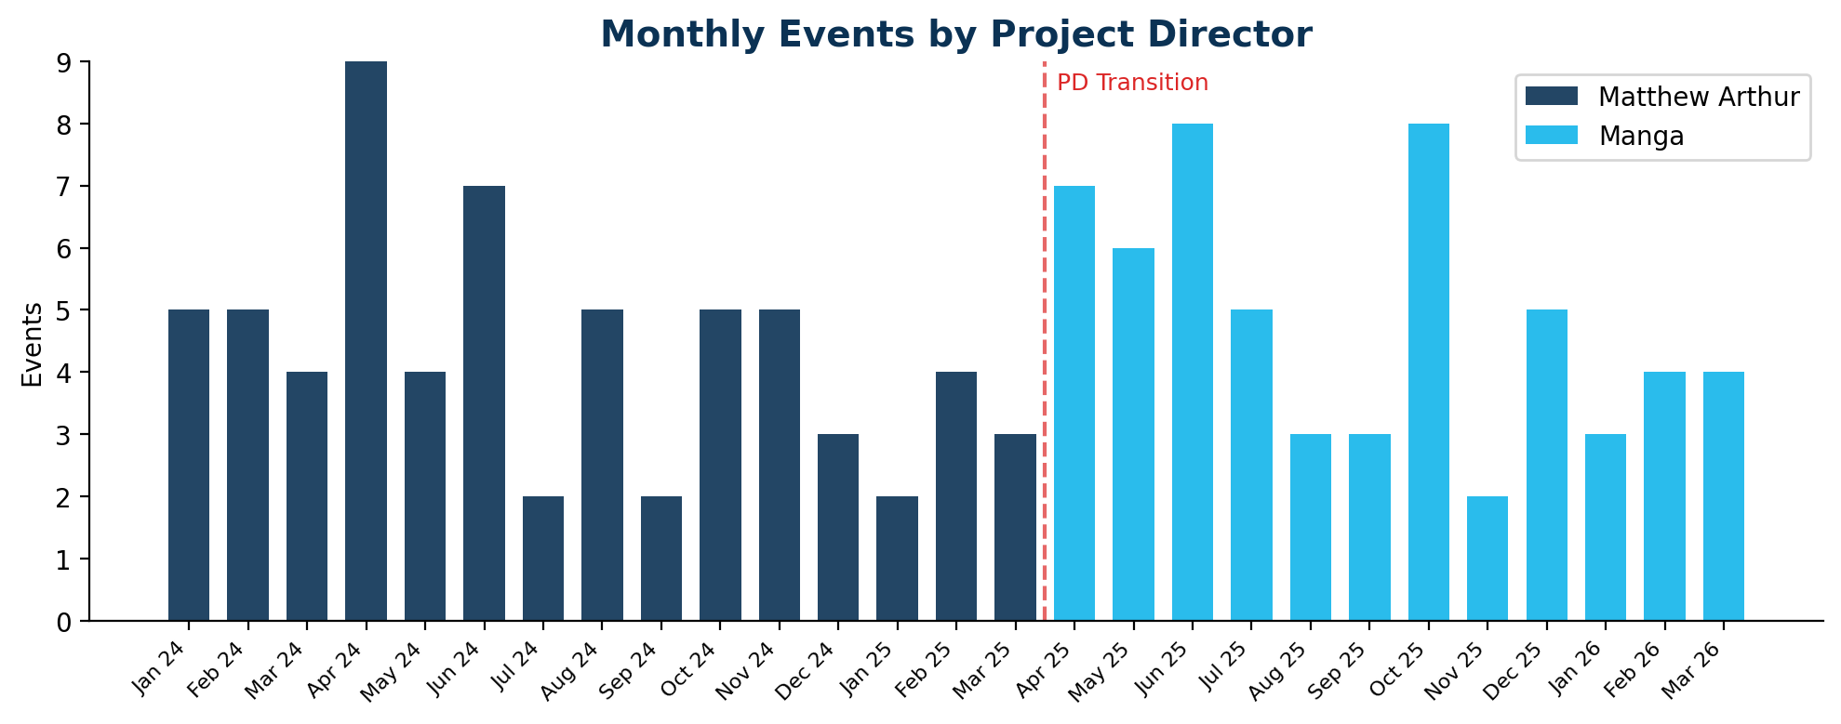

3. Event Type Comparison
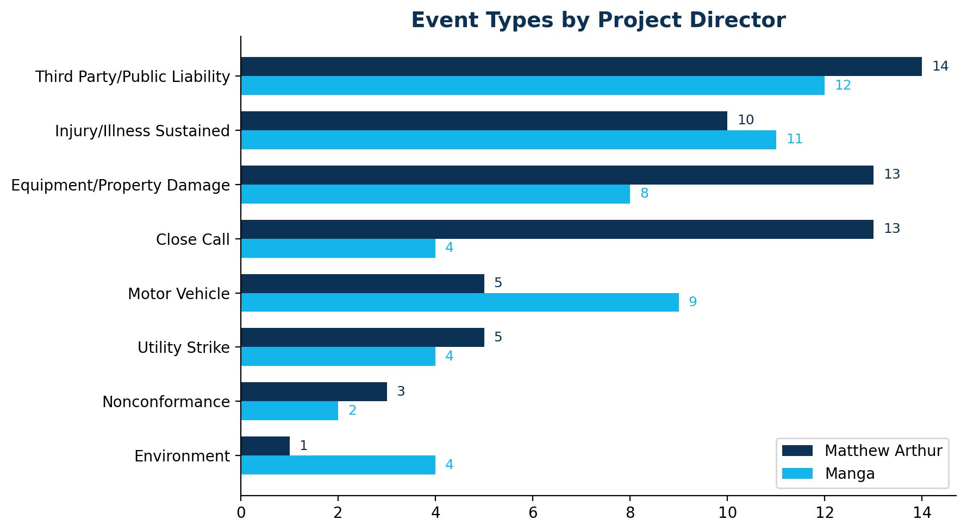
Event Type | Matthew Arthur | % | Manga | %
Third Party/Public Liability | 14 | 21.5% | 12 | 20.7%
Injury/Illness Sustained | 10 | 15.4% | 11 | 19.0%
Equipment/Property Damage | 13 | 20.0% | 8 | 13.8%
Close Call | 13 | 20.0% | 4 | 6.9%
Motor Vehicle | 5 | 7.7% | 9 | 15.5%
Utility Strike | 5 | 7.7% | 4 | 6.9%
Nonconformance | 3 | 4.6% | 2 | 3.4%
Environment | 1 | 1.5% | 4 | 6.9%
Security | 1 | 1.5% | 3 | 5.2%
Assault | 0 | 0.0% | 1 | 1.7%

Notable shifts:
- Equipment/Property Damage decreased: 20.0% → 13.8% (13 → 8 events).
- Close Call decreased: 20.0% → 6.9% (13 → 4 events).
- Motor Vehicle increased: 7.7% → 15.5% (5 → 9 events).
- Environment increased: 1.5% → 6.9% (1 → 4 events).

4. Injury Analysis

4.1 Injury Classification
Classification | Matthew Arthur | Manga
First Aid Treatment | 7 | 2
Report Only | 1 | 5
Non-Work Related | 1 | 3
Lost Time Injury | 0 | 2
Medical Treatment Injury | 1 | 0

4.2 Body Parts Injured
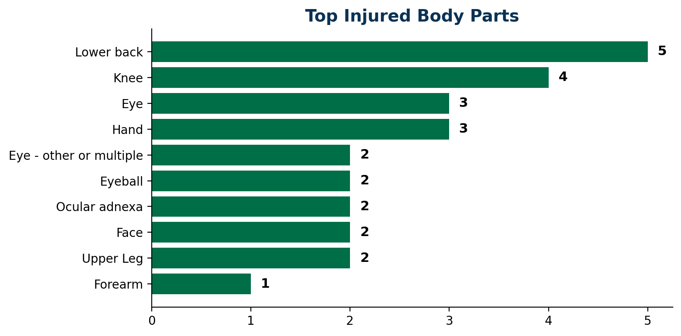
Body Part | Matthew Arthur | Manga
Lower back | 3 | 2
Eye | 2 | 1
Upper Leg | 2 | 0
Hand | 2 | 0
Eye - other or multiple | 1 | 1
Eyeball | 1 | 0
Knee | 0 | 4
Face | 0 | 2

5. Consequence Analysis
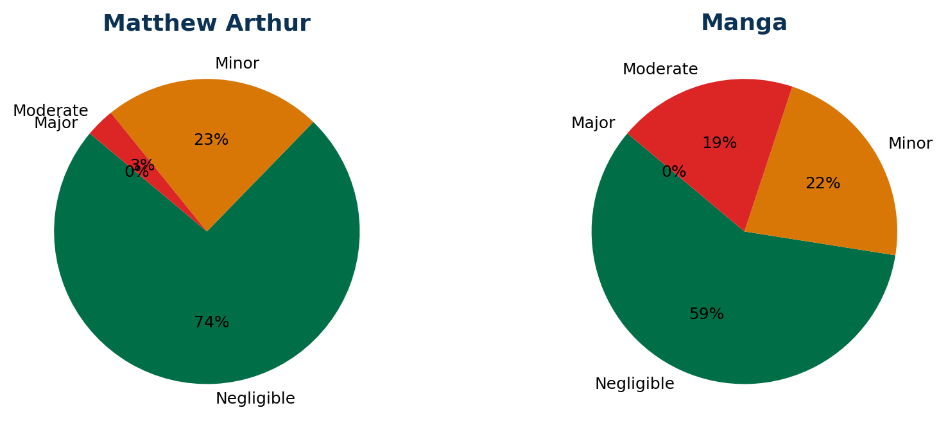
Consequence | Matthew Arthur | % | Manga | %
Negligible | 48 | 73.8% | 34 | 58.6%
Minor | 15 | 23.1% | 13 | 22.4%
Moderate | 2 | 3.1% | 11 | 19.0%
Major | 0 | 0.0% | 0 | 0.0%

6. Critical Risk Protocols & Root Causes

6.1 CRP Comparison
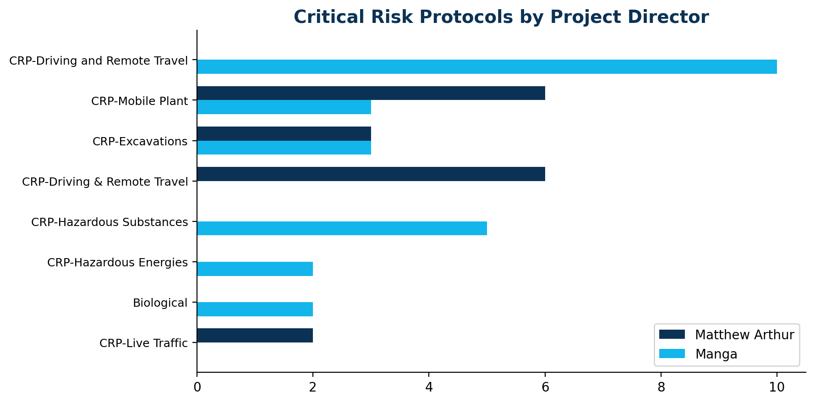

6.2 Root Cause Comparison
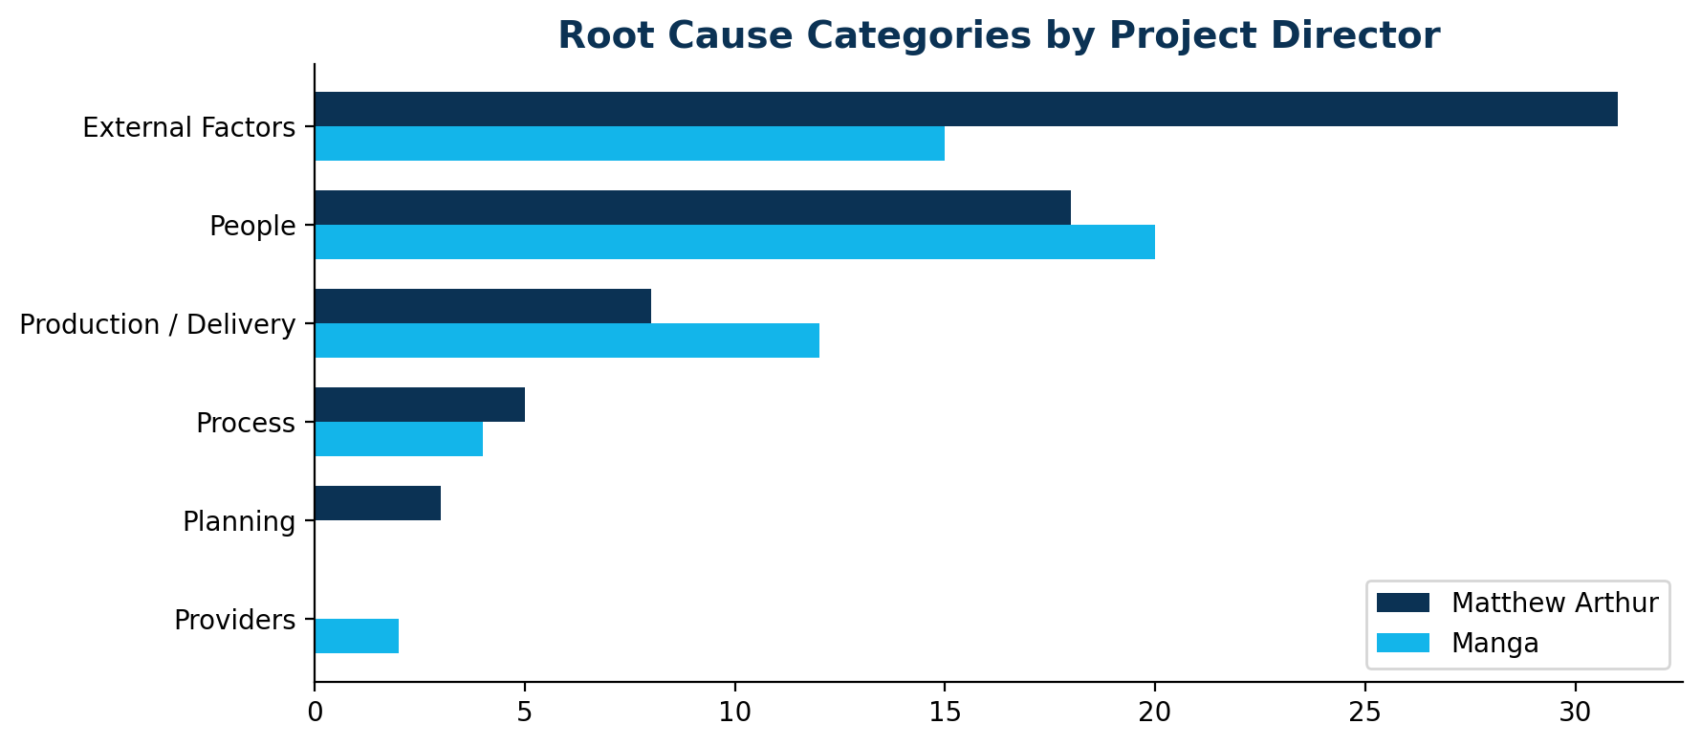
Root Cause | Matthew Arthur | % | Manga | %
External Factors | 31 | 47.7% | 15 | 28.3%
People | 18 | 27.7% | 20 | 37.7%
Production / Delivery | 8 | 12.3% | 12 | 22.6%
Process | 5 | 7.7% | 4 | 7.5%
Planning | 3 | 4.6% | 0 | 0.0%
Providers | 0 | 0.0% | 2 | 3.8%

7. Timing Patterns
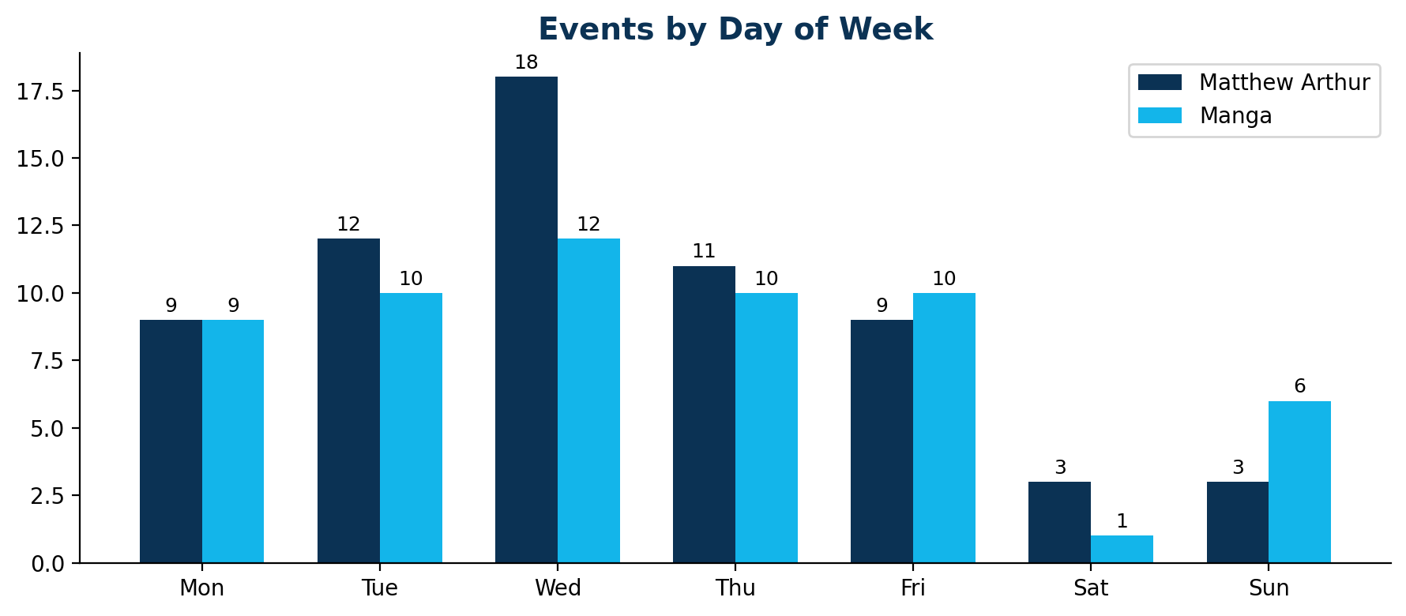

8. Investigation Performance
Metric | Matthew Arthur | Manga
Median Days to Investigate | 15 | 14
Mean Days to Investigate | 25.3 | 24.4
Median Days to Close | 46 | 44
Mean Days to Close | 58.4 | 51.7
Events Closed | 65 (100%) | 48 (83%)
Events Open | 0 | 10

9. Key Findings & Recommendations

9.1 Areas Requiring Attention (Manga Period)
- Motor vehicle events have increased — reinforce journey management plans and reversing protocols.
- Moderate+ consequence events have increased — investigate whether controls are being bypassed.
- Close call reporting has declined — implement reporting targets and recognise reporters.
- 2 LTIs under Manga vs 0 under Matthew Arthur — review circumstances and RTW processes.

9.2 Systemic Issues (Both Periods)
- Lower back injuries from manual handling at pump stations persist — engineering controls needed.
- Third Party/Public Liability events remain a large category, driven by aging infrastructure.
- Wednesday remains the peak risk day — consider targeted mid-week safety interventions.

9.3 Recommended Actions
- Set a close-call reporting KPI (minimum 10% of all events) and track monthly.
- Implement a motor vehicle safety campaign focusing on reversing and traffic management.
- Schedule quarterly PD safety performance reviews using this report format.

